
MOP 32 – Physical Function and Gait Mat Results Letter Templates
Sample Gait Mat Report from PKMAS

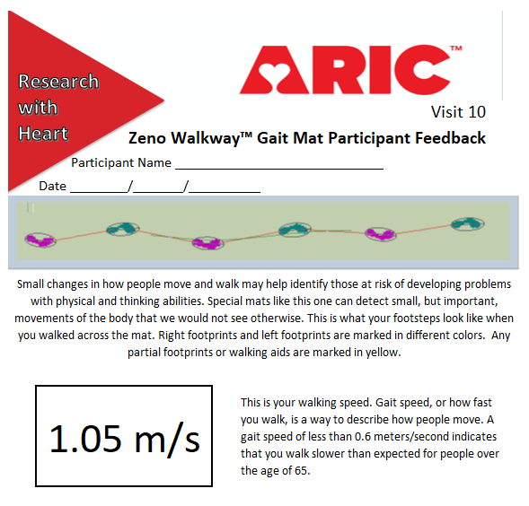

Results included in the Summary of Results Report
MOBILITY AND BALANCE
Mobility is the ability to move or walk and is a key part of healthy aging and living independently. You may receive other mobility-related results if the gait mat component was collected at your clinic visit. Below you will find the results from your assessments of chair stands and balance.

YOUR PHYSICAL FUNCTION ASSESSMENT
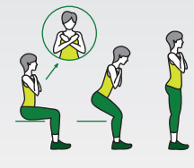
Chair stand. We measured your ability to stand up from a seated position without using your arms.
Chair Stand
Your chair stand performance [was within expected values for someone your age] or [showed that you had difficulty and had to use your arms to push yourself up. This suggests you may have weakness in your legs. This can increase your risk of falling.]


Balance. We measured your ability to keep your balance with the heel of one foot next to the base of the toes on the other foot.
Balance
This balance assessment [was within expected abilities for someone your age] or [showed that you had difficulty keeping your balance with your feet positioned as in the picture (to the right). This suggests you may have problems with your balance and can increase your risk of falling].

