Actigraph Instructions and Log
Thank you for agreeing to wear the Actigraph physical activity monitor at all times for the next full week (with the exception of times when you will be bathing or swimming for longer than 30 minutes). If you have any questions about the device or completion of this form, please contact __________________________ at (_____) _____ - ________.

- A technician will place the Actigraph on your non-dominant wrist at the conclusion of your clinic visit. Please wear the Actigraph device at all times on your non-dominant wrist for the next seven days as shown in the photos below.

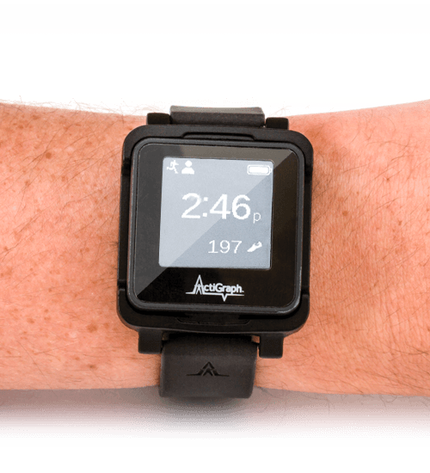
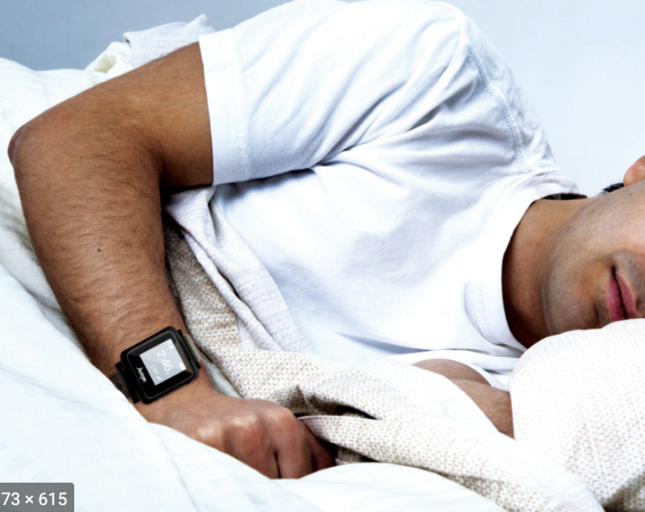

- To help us identify the time that you went to bed each night with the intention of sleeping, please complete the table below each day:
 | Date and time went to bed for the night |  |  | Date and time got out of bed for the day
 | MM / DD / YY | HH : MM AM / PM  (circle one) |  | MM / DD / YY | HH : MM AM / PM  (circle one)
1 | __ __ / __ __ / __ __ | __ __ : __ __ AM / PM |  | __ __ / __ __ / __ __ | __ __ : __ __ AM / PM
2 | __ __ / __ __ / __ __ | __ __ : __ __ AM / PM |  | __ __ / __ __ / __ __ | __ __ : __ __ AM / PM
3 | __ __ / __ __ / __ __ | __ __ : __ __ AM / PM |  | __ __ / __ __ / __ __ | __ __ : __ __ AM / PM
4 | __ __ / __ __ / __ __ | __ __ : __ __ AM / PM |  | __ __ / __ __ / __ __ | __ __ : __ __ AM / PM
5 | __ __ / __ __ / __ __ | __ __ : __ __ AM / PM |  | __ __ / __ __ / __ __ | __ __ : __ __ AM / PM
6 | __ __ / __ __ / __ __ | __ __ : __ __ AM / PM |  | __ __ / __ __ / __ __ | __ __ : __ __ AM / PM
7 | __ __ / __ __ / __ __ | __ __ : __ __ AM / PM |  | __ __ / __ __ / __ __ | __ __ : __ __ AM / PM
8 | __ __ / __ __ / __ __ | __ __ : __ __ AM / PM |  | __ __ / __ __ / __ __ | __ __ : __ __ AM / PM

- We ask that you attempt to wear the device at all times. If you must remove it for any reason, please note the date and time the device was removed from your wrist on the chart below. Please also note when the device was replaced on your wrist. If you plan to bathe or swim for longer than 30 minutes, you should remove the device during that time and replace it immediately after and record in the table below.

Date and time removed |  | Date and time replaced |  | Reason for removal
MM / DD / YY | HH : MM AM / PM  (circle one) | MM / DD / YY | HH : MM AM / PM  (circle one) | Reason for removal
__ __ / __ __ / __ __ | __ __ : __ __ AM / PM | __ __ / __ __ / __ __ | __ __ : __ __ AM / PM
__ __ / __ __ / __ __ | __ __ : __ __ AM / PM | __ __ / __ __ / __ __ | __ __ : __ __ AM / PM
__ __ / __ __ / __ __ | __ __ : __ __ AM / PM | __ __ / __ __ / __ __ | __ __ : __ __ AM / PM
__ __ / __ __ / __ __ | __ __ : __ __ AM / PM | __ __ / __ __ / __ __ | __ __ : __ __ AM / PM

Return Instructions
- Please remove the device from your wrist at or after the removal date and time indicated (meaning no earlier than the time noted here):

Earliest removal date and time:
- Please note the exact day and time you removed the device to mail it back:
Date removed | Time removed
__ __ / __ __ / __ __  MM DD YY | __ __ : __ __ AM / PM  (circle one)

- Please place the device and this paper in the padded mailer provided to you and mail it back to your clinic.
